ACSL
American Computer Science League
2013 - 2014

Contest #3

Junior Division
1. Graph Theory

Draw the directed graph containing the following vertices and edges. Vertices: {A, B, C, D} Edges: {AB, BB, BC, CD, DA, AD, AC}

- Graph Theory

Write the adjacency matrix for
the directed graph.

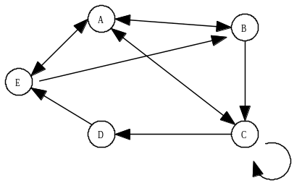

3. Boolean Algebra

Which ordered pairs make the following Boolean expression TRUE?

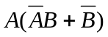

- Boolean Algebra

How many ordered triples make the following circuit TRUE?

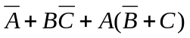

- What Does This Program Do?
Given array A below, what is the final value of C after the program is run?
C = O
FOR I = 1 TO 4
FOR J = 1 TO 4
IF A(I,J)/4 = INT(A(I,J)/4) THEN A(I,J)=A(I,J)/4
IF A(I,J)/3 = INT(A(I,J)/3) THEN A(I,J)=A(I,J)/3
IF A(I,J)/10 = INT(A(I,J)/10) THEN A(I,J)=A(I,J)/10
IF A(I,J)/2 = INT(A(I,J)/2) THEN A(I,J)=A(I,J)/2
NEXT J
NEXT I
FOR I = 4 TO 1 STEP -1
FOR J = 1 TO 4
IF A(I,J) = 1 THEN C = C + 1
NEXT J
NEXT I
PRINT C
END

xxxxxxxxxxxxxxxxxxxx
21 | 8 | 4 | 90
48 | 44 | 1 | 27
70 | 5 | 36 | 10
16 | 40 | 81 | 24

Note: A(1,1) = 16

